Front-End UI/UX Development

Front-End UI/UX Development Mini Project

UI/UX DESIGN FUNDAMENTALS

Project Title:

# Event Registration System – Project Report

**Submitted By**: 

|  |  |  |
| --- | --- | --- |
| Name | Reg no. | E-mail address |
| Akash reddy | 2462347 | Pingali.akash@btech.christuniversity.in |
| Sandeep Siby | 2462358 | [Sandeep.siby@btech.christuniversity.in](mailto:Sandeep.siby@btech.christuniversity.in) |
| Vijay M | 2462373 | [Vijay.M@btech.christuniversity.in](mailto:Vijay.M@btech.christuniversity.in) |

* **Course**:
* **Instructor Name***:* *Mr. Nagaveena*
* **Institution**: christ university(Deemed to be University) kengeri campus
* **Date of Submission**: *13/08/2025*

# Event Registration System – Project Report

**Abstract**

This project focuses on designing and developing a **front-end Event Registration System**. The main goal is to provide a user-friendly interface where users can view events, register online, and access event details efficiently. The project uses **HTML5** for structured content and **CSS3** for styling, layout, and responsiveness. Semantic HTML tags and modern CSS techniques, including **Flexbox**, **Grid**, and **media queries**, ensure accessibility and adaptability across devices. The final outcome is a clean, organized, and visually appealing interface that allows users to register for events smoothly. This project provides practical experience in **responsive web design, UI development, and user-centric design principles**, laying the foundation for future enhancements like JavaScript interactivity and backend integration.

**Objectives**

* Design a **user-friendly interface** for easy event browsing and registration.
* Develop a **fully responsive layout** for desktops, tablets, and mobile devices.
* Implement **structured HTML5 semantic elements** for clear content organization.
* Apply **CSS styling** for branding, layout consistency, and responsive behavior.
* Ensure **accessibility and readability** across all devices.

**Scope of the Project**

* Focused on **front-end design only**.
* No **JavaScript** or **server-side integration**.
* Compatible with **desktop, tablet, and mobile viewports**.
* Used only **open-source tools and pure code**, no libraries.
* Covers structured content, layout, and responsive design for event listings, registration forms, and event details.

**Tools & Technologies Used**

|  |  |
| --- | --- |
| Tool/Technology | Purpose |
| HTML5 | Markup and content structure |
| CSS3 | Styling and layout management |
| VS Code | Code editor |
| Chrome DevTools | Testing and debugging |

**HTML Structure Overview**

* Used semantic tags: <header>, <nav>, <main>, <section>, <footer>.
* Structured into reusable sections: **Home**, **Events**, **Registration Form**, **Contact**.
* Navigation menu using <ul> and anchor links for smooth scrolling.
* Modular structure ensures readability, maintainability, and scalability.

**CSS Styling Strategy**

* Used external CSS file (style.css).
* Organized with **comments and sections** for clarity.
* Techniques used:
  + **Flexbox and Grid** for layout.
  + **Media Queries** for responsiveness.
  + **CSS Variables** for theme customization.
  + **Hover effects and transitions** for interactive elements.
  + **Mobile-first design approach** for optimal mobile usability.

**Key Features**

|  |  |
| --- | --- |
| Feature | Description |
| Responsive Design | Adapts seamlessly to all screen sizes |
| Smooth Navigation | Fixed top nav with anchor links |
| Project Cards | Flex-based layout with hover effects |
| Contact Form (non-functional) | Placeholder layout for inputs and button |
| Accessible Fonts & Colors | High contrast and readable typography |

**Challenges Faced & Solutions**

|  |  |
| --- | --- |
| Challenge | Solution |
| Overlapping elements on small screens | Used media queries to stack elements |
| Difficulty aligning items using float | Shifted to Flexbox and Grid |
| Typography scaling issue | Used relative units (em/rem) instead of px |

**Outcome**

* Achieved a **clean, consistent, and visually appealing front-end layout**.
* All key components functioned as intended using **only HTML and CSS**.
* Gained practical knowledge of **responsive layouts, semantic HTML, and UI hierarchy**.
* Provided a foundation for **future enhancements** like interactive forms and backend integration.

**Future Enhancements**

* **Add JavaScript** for interactivity (form validation, dynamic content).
* **Integrate animations and transitions** for improved user experience.
* **Backend integration** for storing event registrations and managing user data.
* **Theme toggler** (light/dark mode) for personalization and accessibility.

**Sample Code**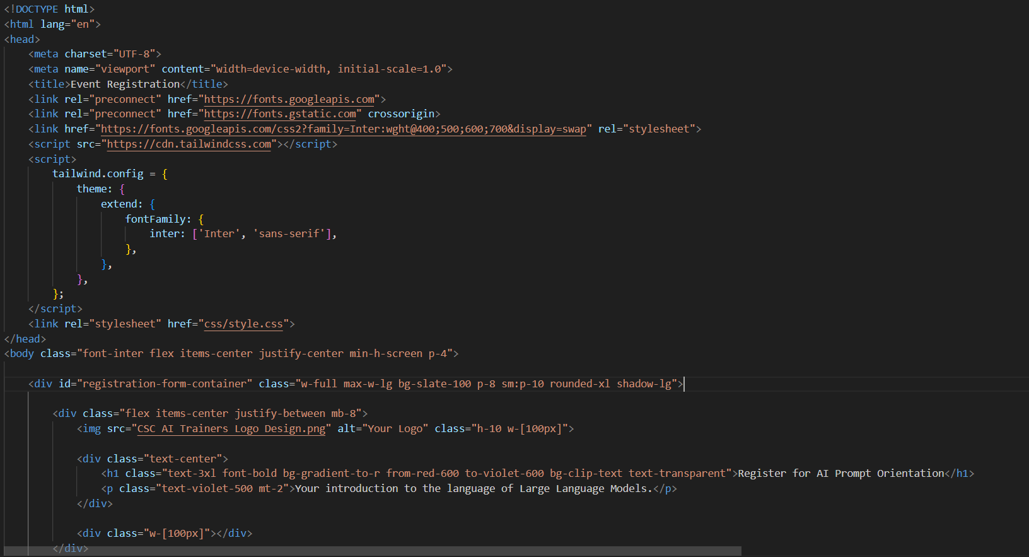

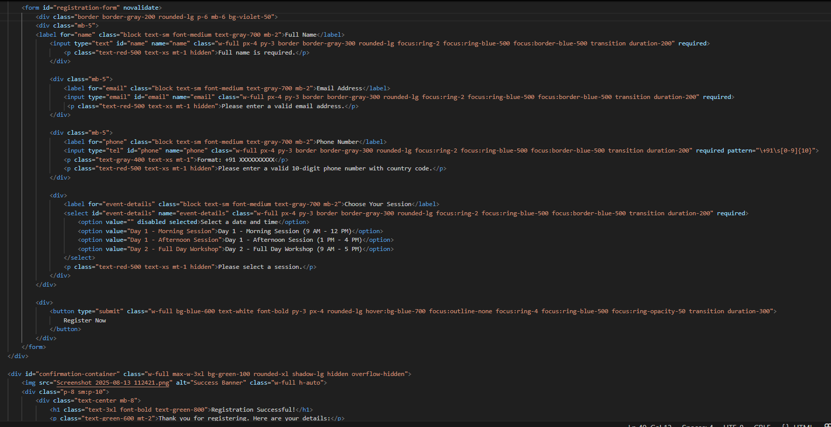

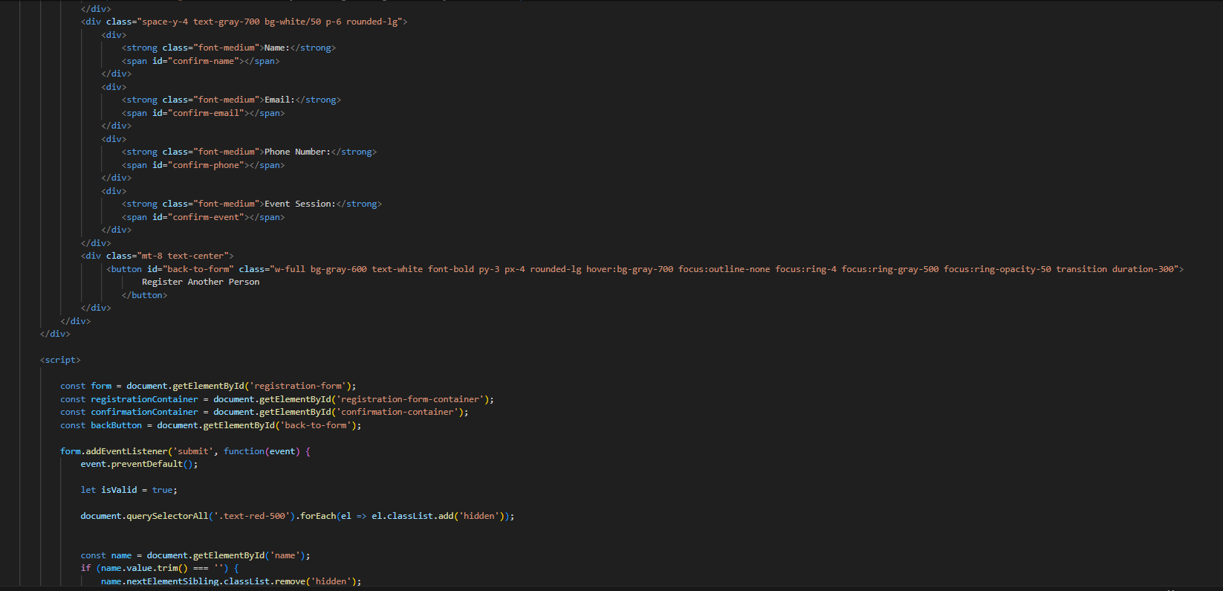

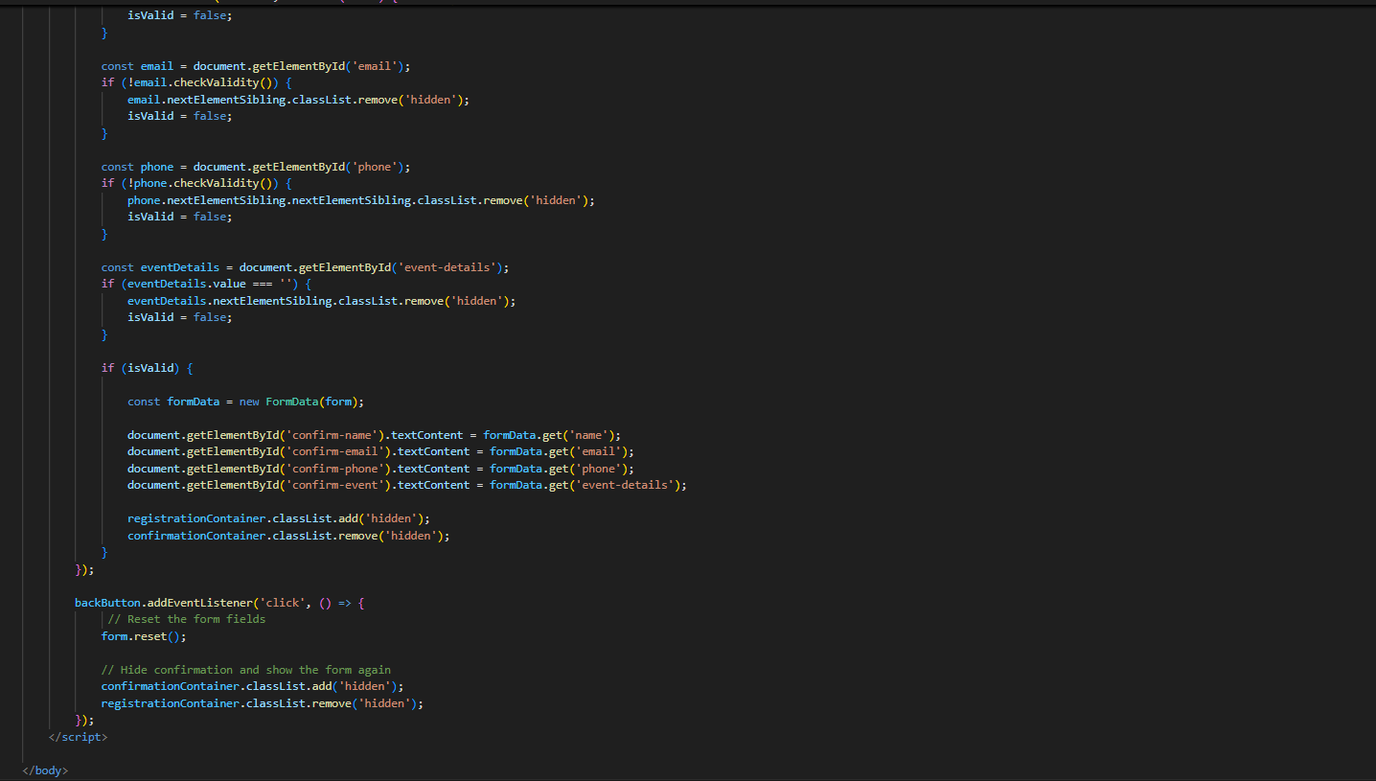

**Screenshots of Final Output**

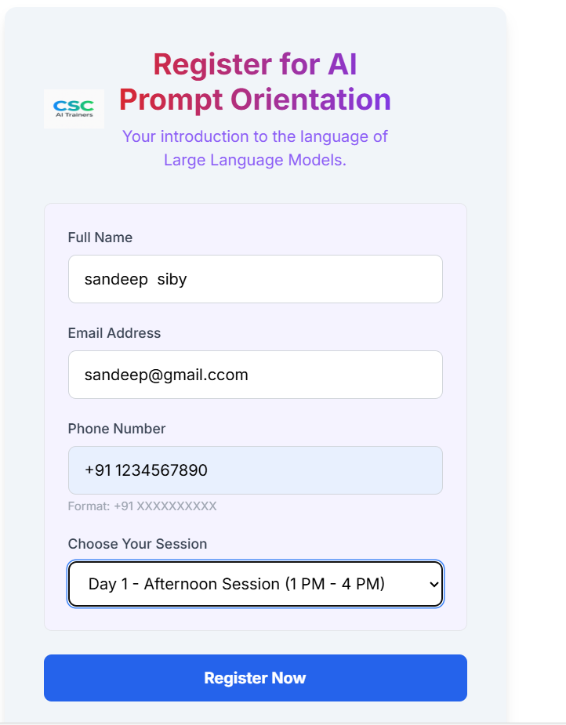



**Conclusion**

This project demonstrates the development of a **front-end Event Registration System** with a clean, responsive, and user-friendly interface. The mini project helped strengthen **front-end development skills using HTML and CSS**, providing insights into **responsive design, layout structuring, and user interface aesthetics**. Implementing these design principles enhanced understanding of **user-centric web design**, forming a strong foundation for future interactivity and backend integration.

**References**

* L&T LMS: <https://learn.lntedutech.com/Landing/MyCourse>